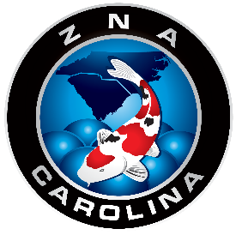
2018 ZNA CAROLINA MEMBERSHIP FORM
FACEBOOK PAGE: ZNA CAROLINA
JASON GUEVARA, M.D., PRESIDENT
EMAIL: unispacer@aol.com

ZNA Carolina is the first ZNA Friendship Chapter representing the Carolinas and surrounding states, and officially recognized in Beppu Japan as of May 10, 2014. Our mission is to enhance your appreciation of Koi and how to take care of them. A full member will be recognized in Japan and receive a monthly Nichirin magazine. Welcome to ZNA Carolina! Membership is from May to May.

Please check the appropriate membership box:

Full Membership $120.00 for 1 year (Includes Nichirin Magazine)
Spouse Membership $ 20.00
Friendship Membership $ 40.00
Second ZNA Club Membership $ 30.00
Vendor Membership $ 75.00
You can pay by PayPal but use the friends and family gift payment

NAME(S) (Mr. Dr. Mrs. Miss) _________________________________________DATE: _____________

MAILING ADDRESS ___________________________________________________________________
(Street or PO Box) (City) (State) (Zip) (Country)

TELEPHONE ( )______________________ ( )_______________________ (Home) (Cell)

EMAIL _____________________________________________________________________________

MEMBERSHIP PAYABLE BY CHECK TO: ZNA CAROLINA
501 CHICKEN PLANT ROAD
ABERDEEN NC 28315

*A RECEIPT WILL BE SEND VIA EMAIL

